Data Analytics With Tableau

Name : Mohammad Salma

Team Member – 2 Assignment - 1

Supermarket Sales Data Analysis Report – Tableau Visualizations

Bar Chart: Total Sales by Product Line

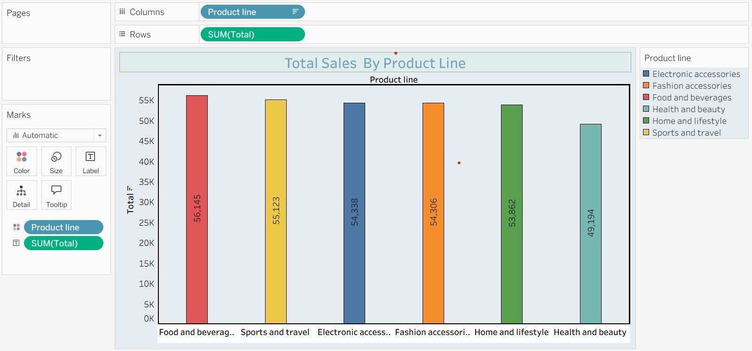

This bar chart compares the total sales for each product line.

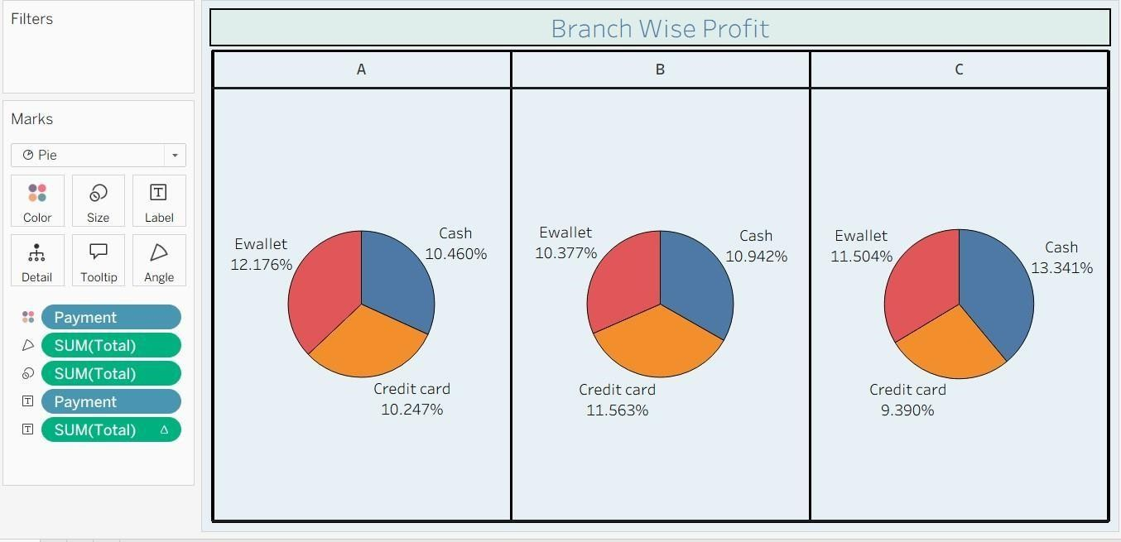
Pie Chart: Branch Wise Profit
This pie chart shows the proportion of total sales made through different payment methods.

Stacked Bar Chart: Branch-wise Sales by Gender
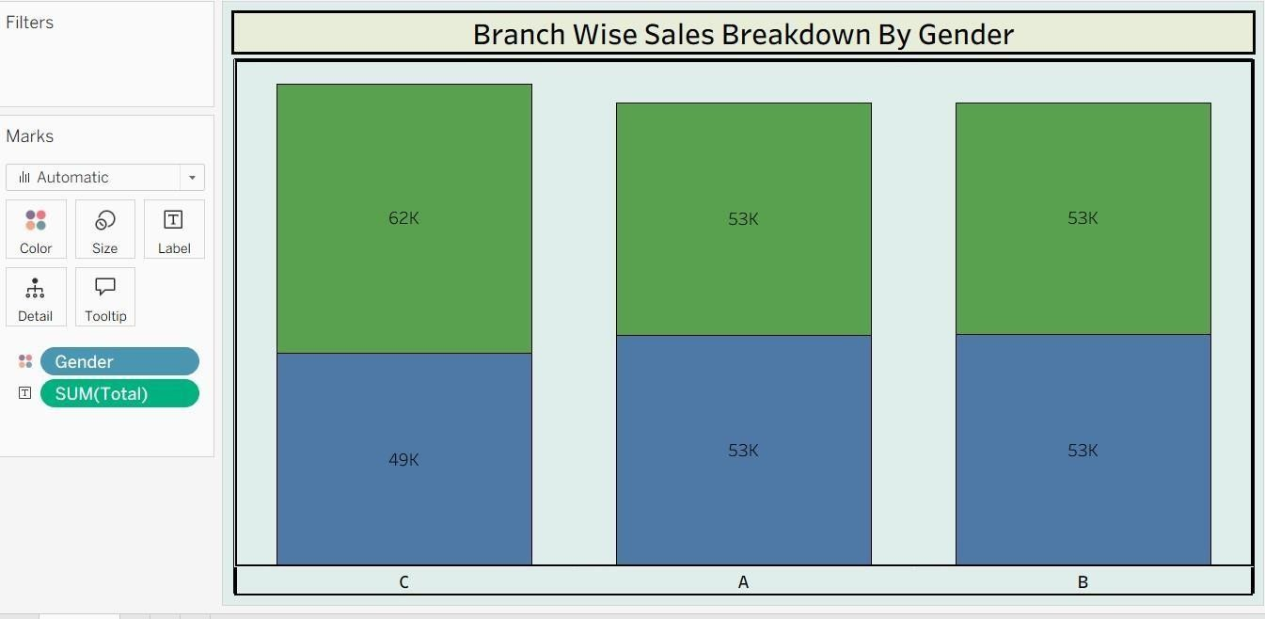
Each branch’s sales are broken down by gender to analyse customer contribution.

Line Chart: Month-wise Sales
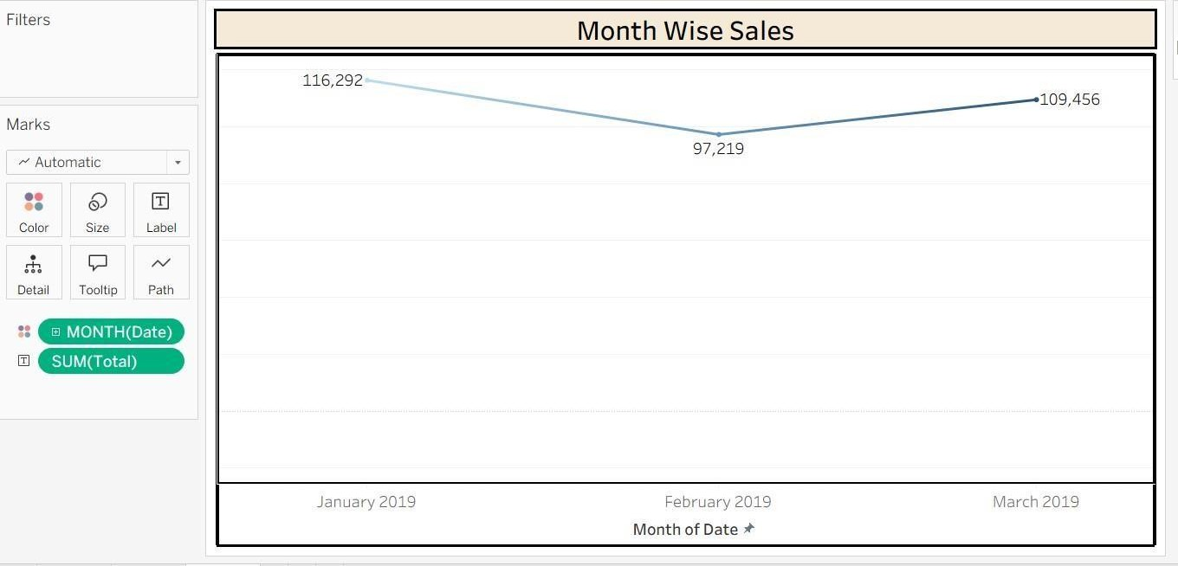
This line chart shows how total sales have varied from January to March.

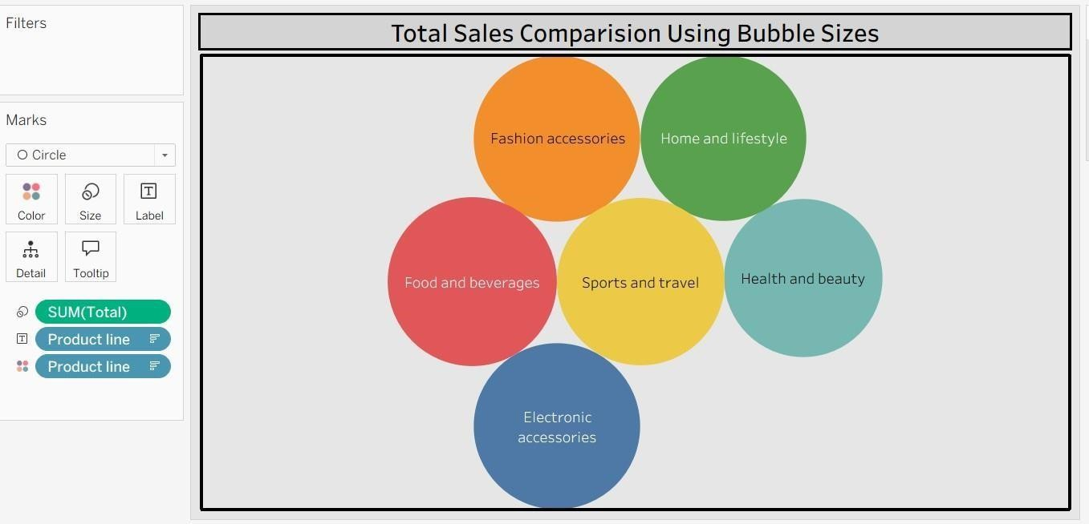
Bubble Chart: Product Line-wise Sales

Each bubble represents a product line, its size indicates total sales volume.

